**HISTORY OF BATTERY CARS:**

1. The trial battery motor was invented in the same period of the petroleum engines and motors.
2. The inventor from Hungarian ANYOS JEDLIK in 1828 made the first proto type of the electric motor.
3. The inventor named THOMAS DAVENPORT in 1834 made a proto type of electric tram cart (using electric track).
4. The NETHERLANDS inverter SIBRANDUS STRATINGH build a car with a non-rechargeable cart.
5. The regular cell battery was not viable as it would take more space and large number of batteries and they are multi usable.
6. In the year 1859 the French physicist GASTON PLANTE the invented the lead acid battery. Made a great leap in the battery industry.
7. The USA made a huge in the year 1891 they created the first electric vehicle. It was a 6-seater wagon, it could move 23kmph.
8. The early 1890s the roads of LONDON were running with the electric taxis.
9. In those days as compared to the petrol and steam the electric motors were much better as compared in the categories.
10. But due to the lack of investment and research towards the basic part the battery was almost null as compared to the steam engines.
11. Later when the car engines were made on the dependences of petrol and kerosine, the service for the engine was seasonal but wasn’t a daily process like battery cars.
12. So, the market moved towards the petroleum engines and stopped using the tech of batteries for locomotion, as there was a halt of funding there was no development in the battery dependent transportation.

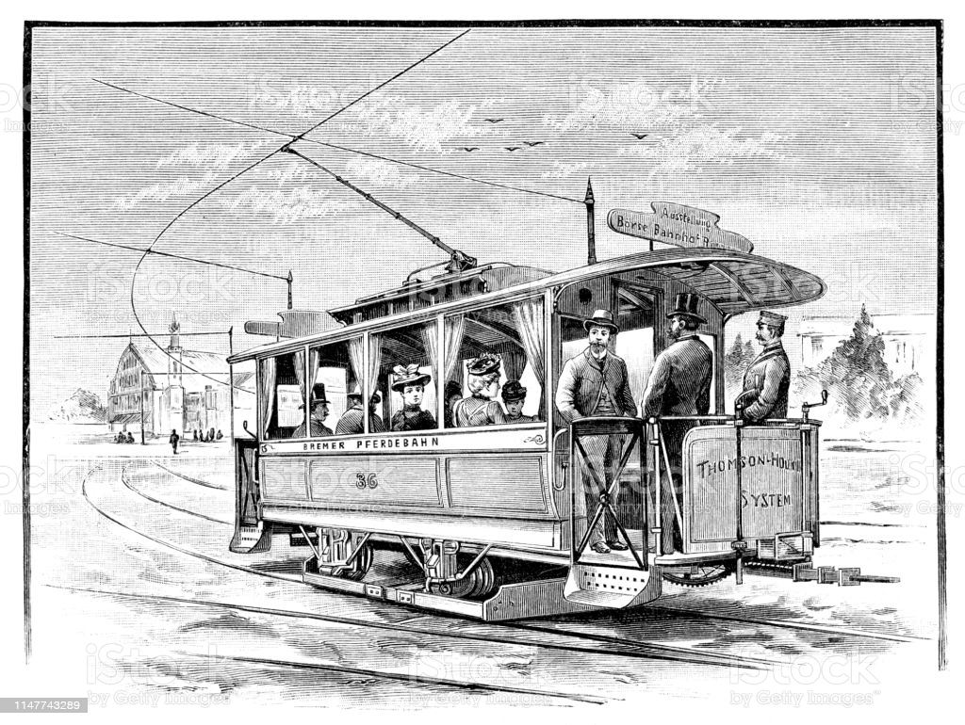

**New vehicle estimated real-world CO2 emissions are at a record low and fuel economy is at a record high**

Since 2004, CO2 emissions have decreased 23%, or 108 g/mi, and fuel economy has increased 30%, or 5.8 mpg. Over that time, CO2 emissions and fuel economy have improved in twelve out of fourteen years and have repeatedly achieved new records. The trends in CO2 emissions and fuel economy since 1975 are shown.

In model year 2018, the average estimated real-world CO2 emission rate for all new vehicles fell by 4 grams per mile (g/mi) to 353 g/mi, the lowest level ever measured. Fuel economy increased by 0.2 miles per gallon to 25.1 mpg, achieving a record high.

Preliminary data suggest further improvements in model year 2019. Average estimated real-world CO2 emissions are projected to fall 6 g/mi to 346 g/mi and fuel economy is projected to increase 0.4 mpg to 25.5 mpg.

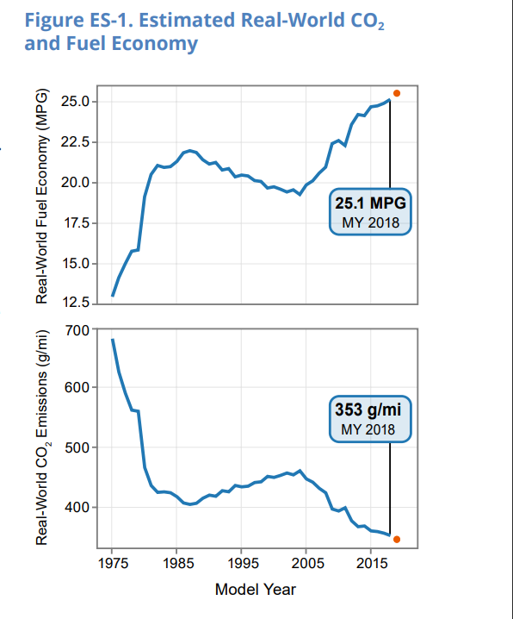

OBSERVATION:

AS we can see the MILES PER GALLON have increased by the years and the pollution emitted GRAMS PER MILES are reduced due to the improvement of the engine.

This gives the clear picture of how the oil engines have evolved across years.

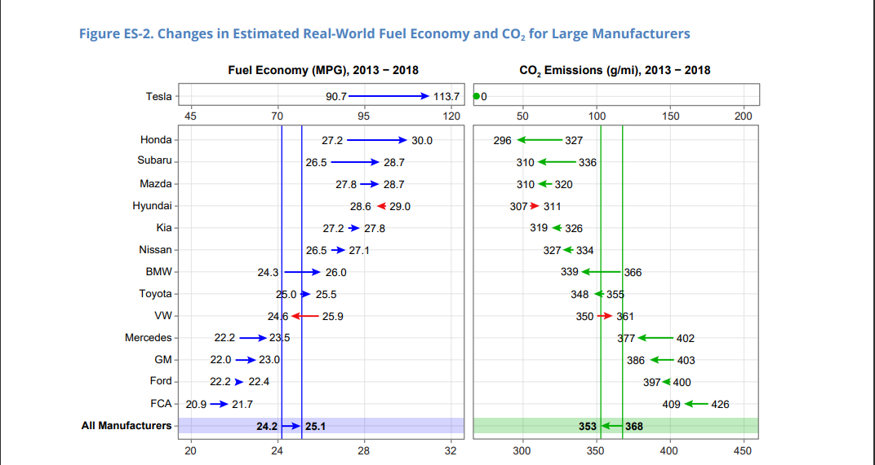

NOTES:

THIS IS THE PICTURE OF DIFFERENT COMPANIES IMPROVENMENT IN MILAGE AND REDUCTION OF POLLUTION MATERIALS INTO THE ENVIRONMENT.

AT THE END AVERAGE OF ALL COMPANIES AND THEIR CONTRIBUTIONS TOWARDS THE MILAGE ANDPOLLUTING ELEMENTS INTO ENVIRONMENT.

THIS ARE THE DEVELOPMENT AREAS IN WHICH THE DIFFERENT AUTOMOBILE COMPANIES CHANGED

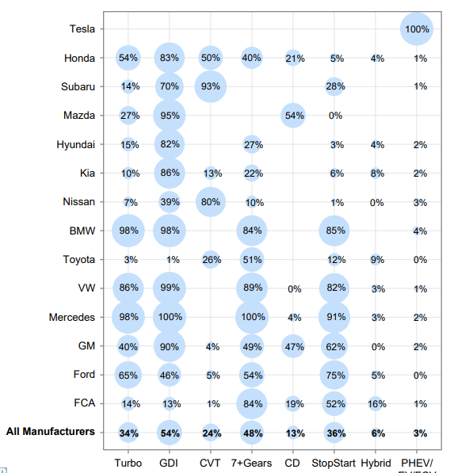

ESTIMATED RFE, HORSEPOWER AND WEIGHT

